FPGA DESIGN AND IMPLEMENTATION REPORT
(Write the name of your digital system here)

1) Design description.
- Write a description of the digital system and its behaviour.
- Fill in a table for each significant circuit of the digital system you are describing and for the top file, with the following information:
Write the name of your circuit here (file_name.vhd)
begin

AAND: p_and port map (a => entrada1,
b => entrada2,
res => P);

CCA2: Compl_a2 port map (a => entrada1,
c_a2 => Q);

RRES: Resta port map (a => entrada1,
b => entrada2,
res => R);

PPROD: Prod port map (a => entrada1,
b => entrada2,
res => S);

P1 <= "0000" & P;
Q1 <= std_logic_vector (resize (signed (Q),8));
R1 <= std_logic_vector (resize (signed (R),8));

MMUX: MUX port map (p_and => P1,
c_a2 => Q1,
resta => R1,
prod => S,
sel => selector,
Y => salida);

end Alu;
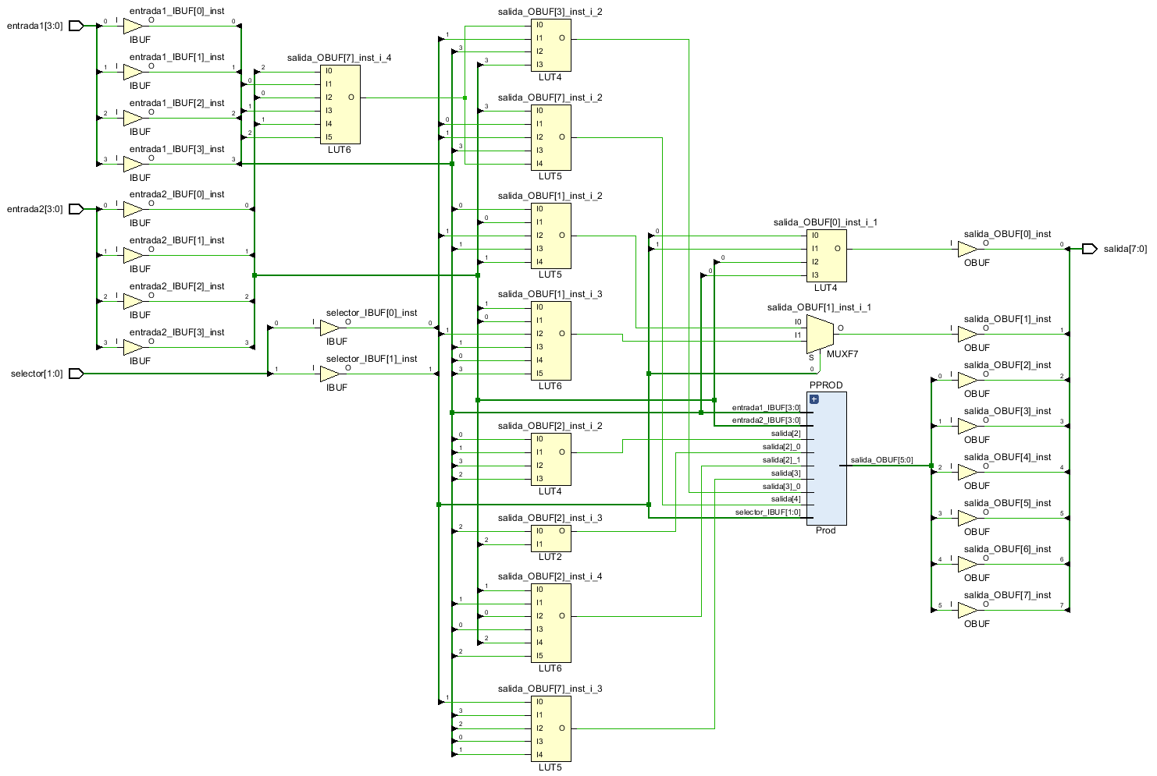
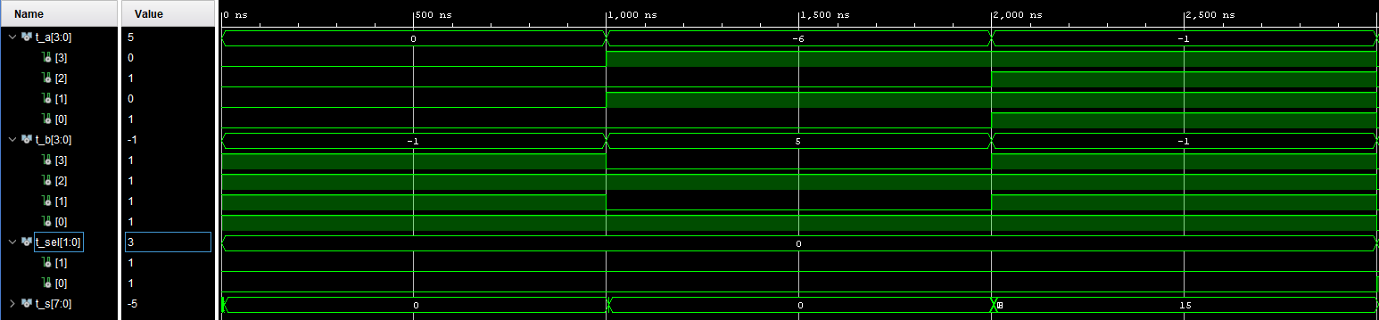
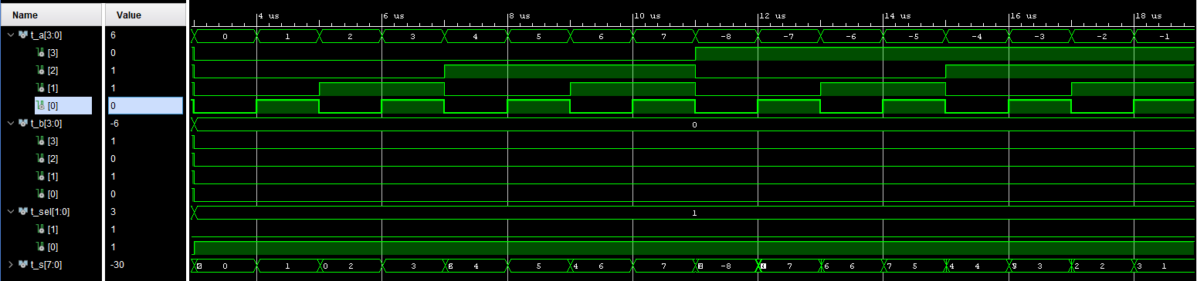
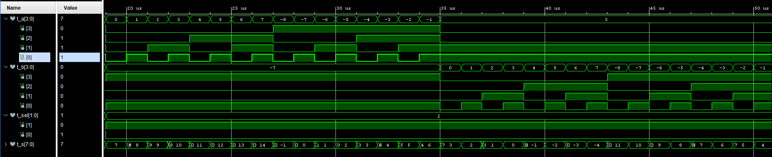
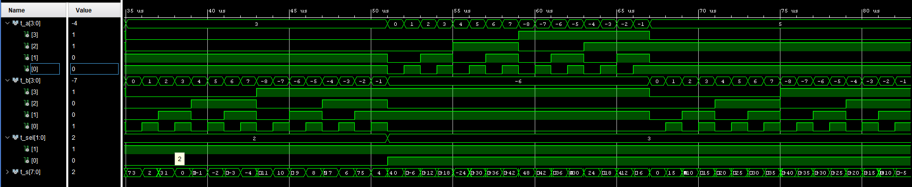
2) Implementation analysis.
FPGA: XC7A35T-CPG236-1 C
2.1. FPGA resource analysis:
 | Slices (total) | Slice LUTs | Bonded IOBs
ALU | 10 | 29 | 18

3) Conclusion.
Explain if everything has worked as expected, if the FPGA resources used and the final delays are correct, and any other special circumstance worth mentioning.
Todo funciona como lo esperado, solo que en el componente del complemento a2 cuando la entrada es -8 la salida también, y el complemento a2 de -8 es 8.

